Flower Festival 26th -28th May

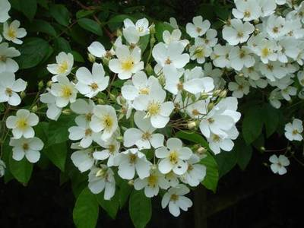

To celebrate the 600th anniversary of our beautiful village church of St Dunstan in Bolnhurst [MK44 2HB] there will be a three day Flower Festival next weekend on Saturday, Sunday and Monday from 11am to 4pm..

Flowers [of course!] but also popular local singers 'One over the Eight' singing on Saturday at 2pm, Holy Communion on Sunday at 10am with the bells being rung and then in the afternoon two organists will play for you.

On Monday Bedford Embroiderers will bring a display and demonstrate their work. Every day there will be children's activities, teas and homemade cakes and a raffle running through the Festival which will be drawn on Monday.

A wonderful weekend is promised!